**PYTHON DRIVER CONTROLLING OSCILLOSCOPE PROJECT**

Aryan Kumar – PES1UG21EC058

**WHAT IS A OSCILLOSCOPE ?**

An oscilloscope, also known as an o-scope, is a type of electronic test instrument used to measure and display waveform patterns of electrical signals. It is commonly used in the fields of electronics, telecommunications, and engineering .

An oscilloscope works by displaying the voltage of an input signal over time, typically as a two-dimensional graph, with voltage on the vertical axis and time on the horizontal axis. The display is created by an electron beam scanning across a phosphor-coated screen, which emits light when struck by the beam .

Oscilloscopes come in different types and models, ranging from simple analog devices to sophisticated digital models with advanced features such as automatic measurements, storage, and analysis of waveforms. They can be used to measure a wide range of signals, including AC and DC voltages, frequencies, and complex signals like waveforms from microcontrollers, audio signals, and data communications signals .

**NEED TO CONTROL BY SOFTWARE ?**

Many oscilloscopes today come with software applications that allow you to remotely control the device via a computer or mobile device. This type of software is often referred to as a "remote control application" or "remote control software" .

The remote control software typically provides a graphical interface that replicates the controls and features of the oscilloscope, allowing you to operate the device using your computer or mobile device. You can use the software to adjust the settings of the oscilloscope, acquire and display waveforms, make measurements, and perform other functions .

Some oscilloscope manufacturers also provide software development kits (SDKs) that allow you to develop custom software to control the device. This can be useful if you need to integrate the oscilloscope into a larger system or develop custom data analysis tools. By using SCPI commands it can be programmed as SCPI command are standard for all oscilloscope .

To control an oscilloscope using software, you typically need to connect the device to your computer or mobile device using a USB or Ethernet cable, and install the appropriate software and drivers. The specific steps will depend on the make and model of the oscilloscope and the software you are using .

**SOFTWARE DEVELOPED USING**

MODEL USED = DS1054Z

Programming Guide = [MSO_DS1000Z_ProgrammingGuide_EN.pdf (batronix.com)](https://www.batronix.com/files/Rigol/Oszilloskope/_DS&MSO1000Z/MSO_DS1000Z_ProgrammingGuide_EN.pdf)

User Guide = [DS1000Z_UserGuide_EN.pdf (batronix.com)](https://www.batronix.com/pdf/Rigol/UserGuide/DS1000Z_UserGuide_EN.pdf)

Data Sheet = [DS1054Z Rigol - Datasheet PDF & Technical Specs (allaboutcircuits.com)](https://www.allaboutcircuits.com/electronic-components/datasheet/DS1054Z--Rigol/)

# Programming Language Used = Python( In Command Prompt) , SCPI

# ( Standard Commands for Programmable Instruments )

# Note – Download vxi11 to have interface with ethernet and

# device = [GitHub - python-ivi/python-vxi11: Provides a VXI-11 driver for controlling instruments over Ethernet](https://github.com/python-ivi/python-vxi11)

( Before running the program please go through README )

**SOFTWARE FEATURES**

* To run the program go inside the folder Oscilloscope Driver and go inside the folder program and find the Oscilloscope_driver.exe file and double click on it .
* Any problem pls refer to readme document in the folder Oscilloscope Driver .

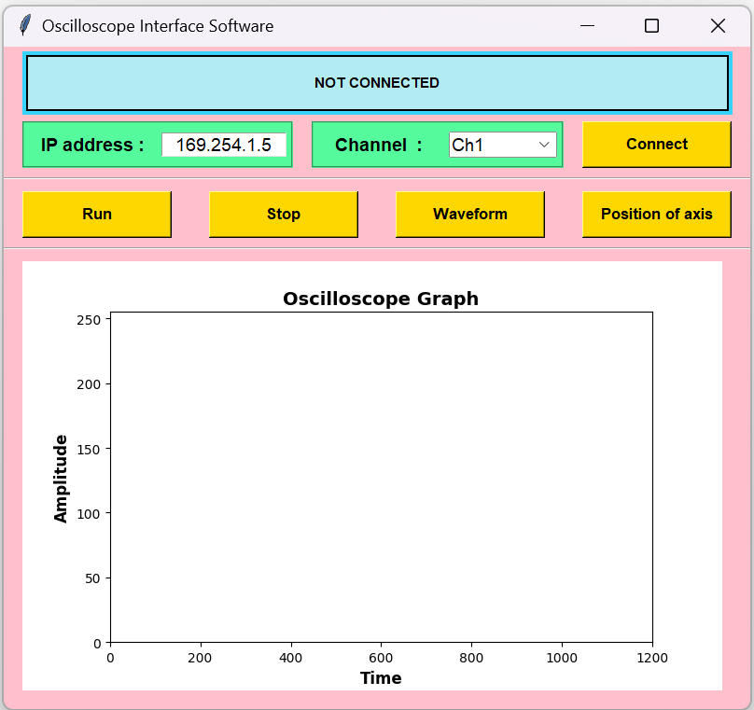

**1. TO CONNECT –**

* Type in the IP Address of the connection shown by the device in its IP configuration settings .

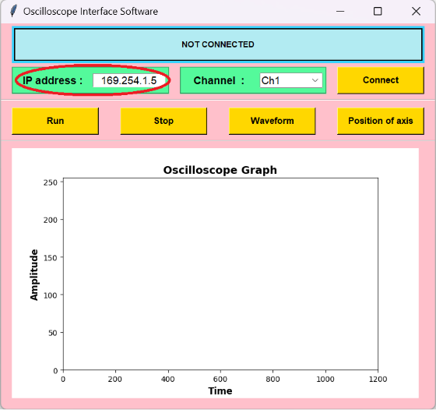

* Press “Connect” button to establish link between device .

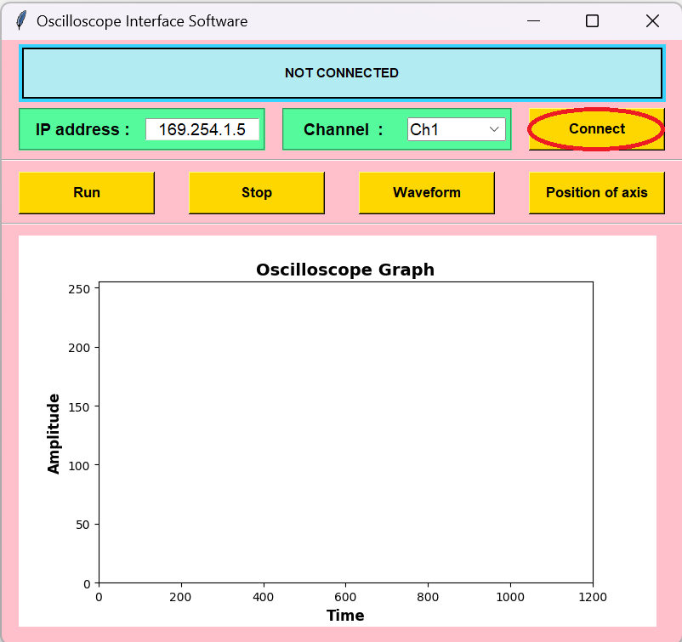

* If the device is not connected the top text will say “NOT CONNECTED” and pressing any of the buttons will show a error message .

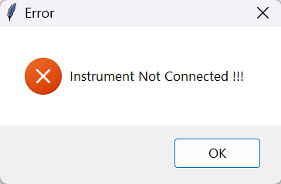

* If the device gets connected then the top text will say the device name and serial number .

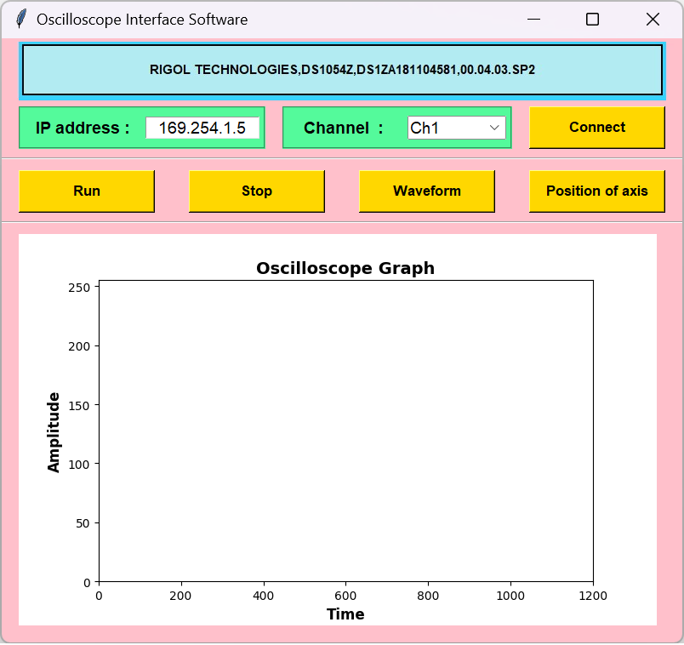

**2. TO CHOOSE CHANNEL OF OSCILLOSCOPE –**

* Choose the channel desired to be displayed from oscilloscope .

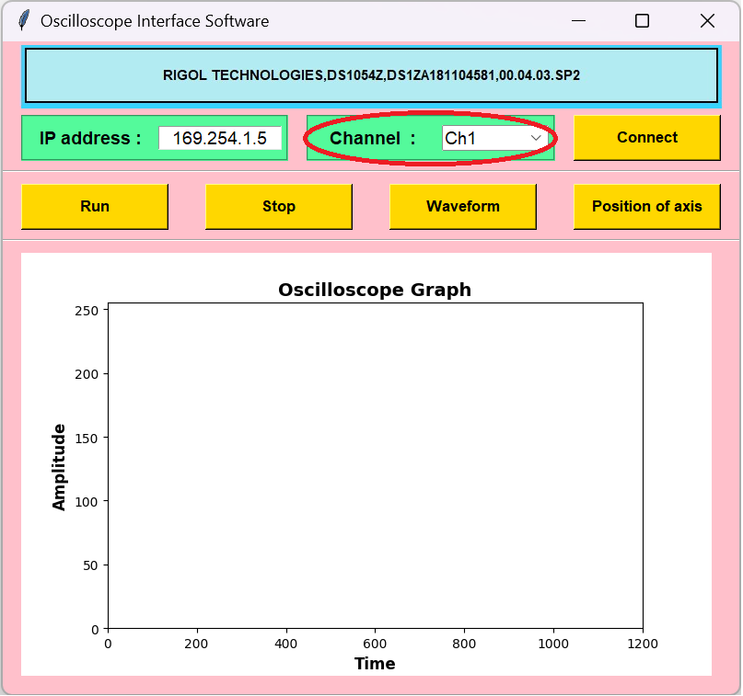

**3. TO RUN –**

* Press on “RUN” button to activate oscilloscope .

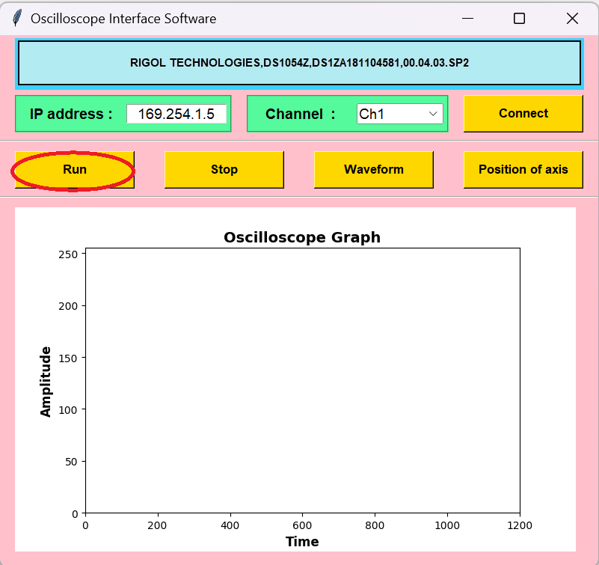

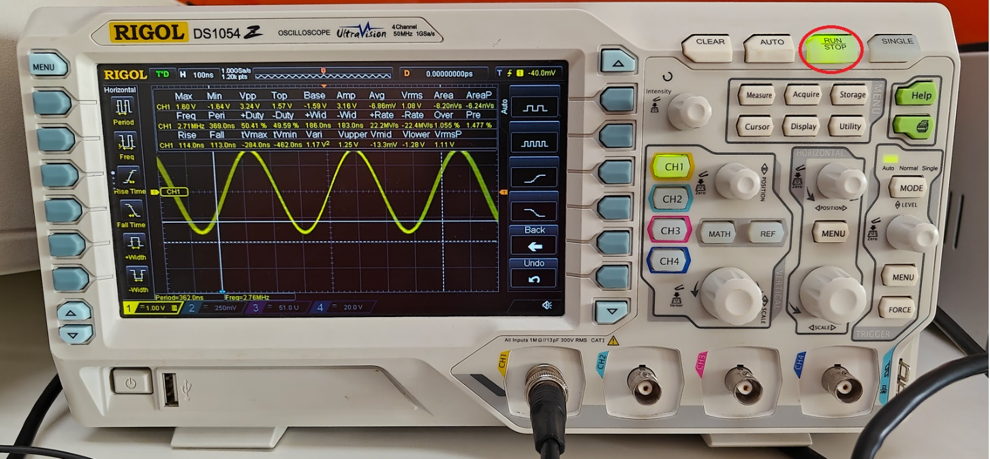

**4. TO STOP –**

* Press on “STOP” button to stop oscilloscope .

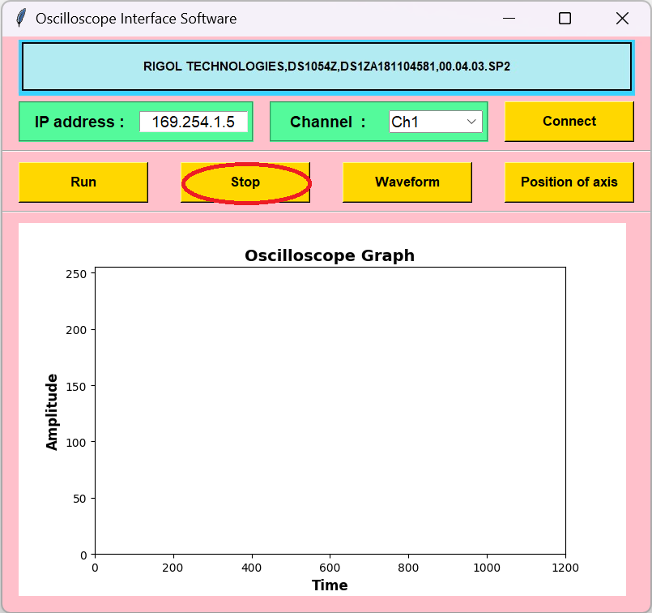

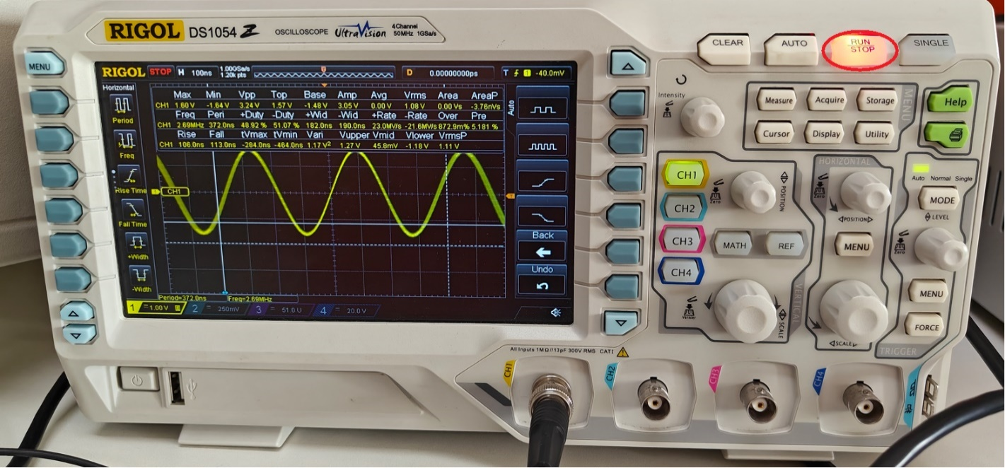

**5. TO SHOW WAVEFROM –**

* Press on “Waveform” button will give the raw data and plots it one the graph and it takes only 1200 points of value from the oscilloscope .
* It also Prints the raw data , hex data , integer data in a text format in the desired filename of the user which can be edited in code .
* The data in text format is saved in a file called “output.txt” .

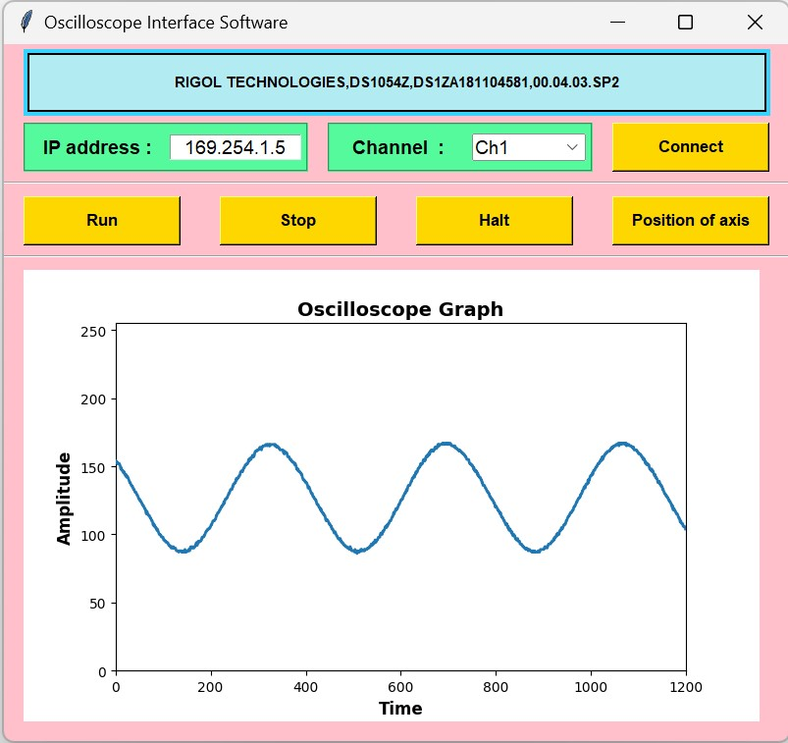

* Few more examples :

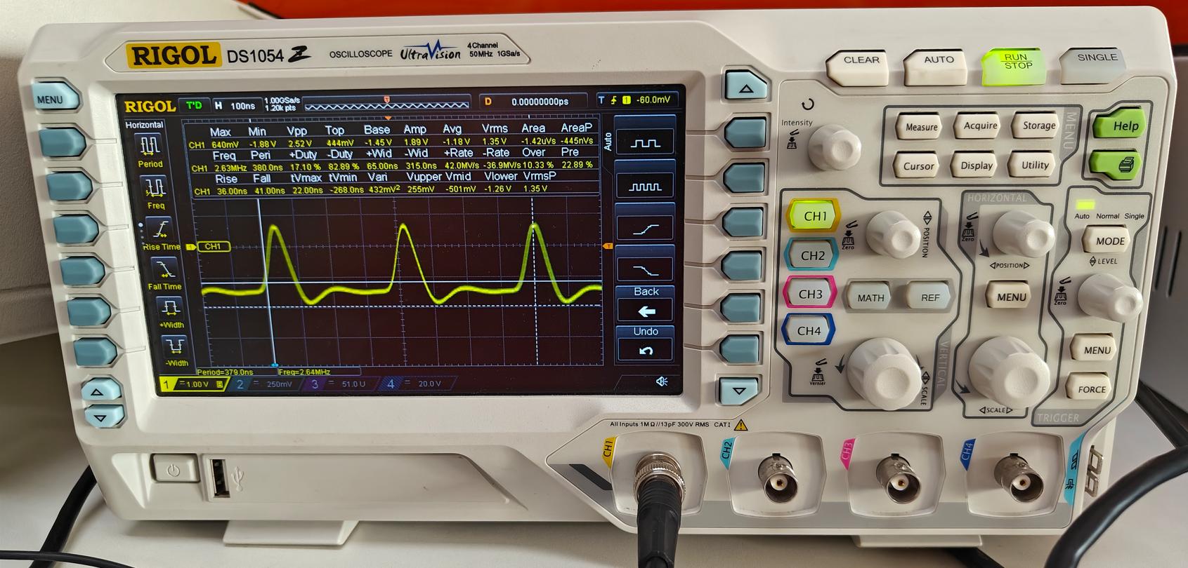

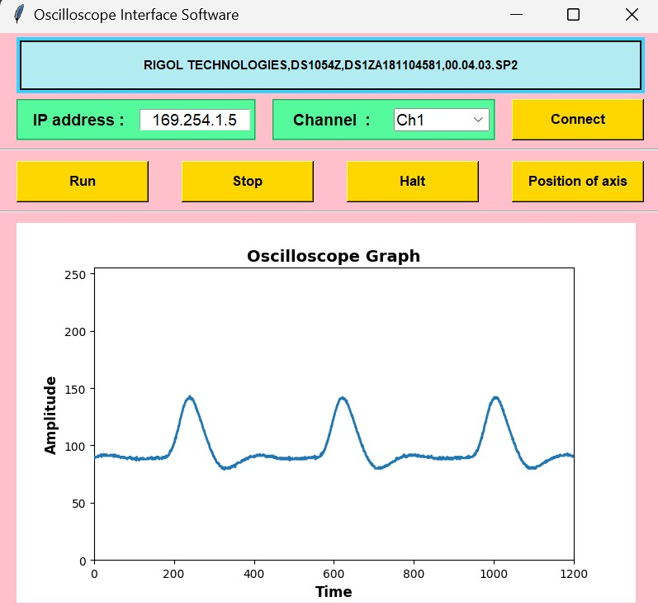

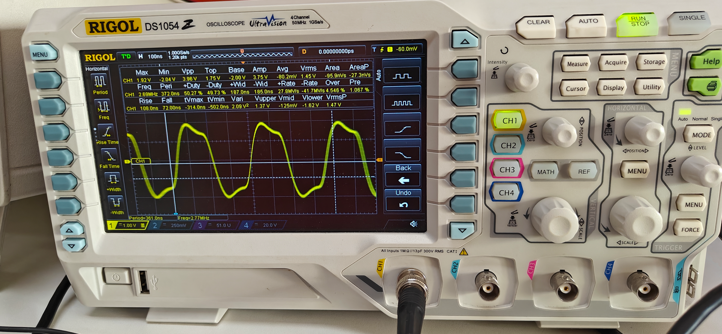

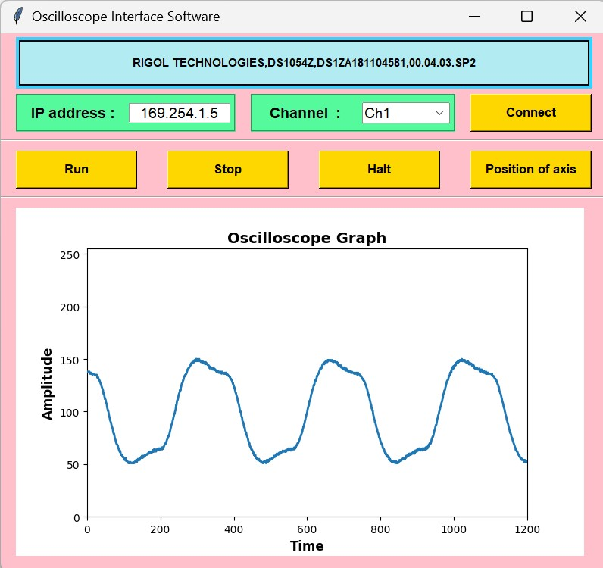

**6. TO GET AXIS ORIGIN VALUES –**

* Press on “Position of axis” button to get x and y origin values of the graph on the oscilloscope.

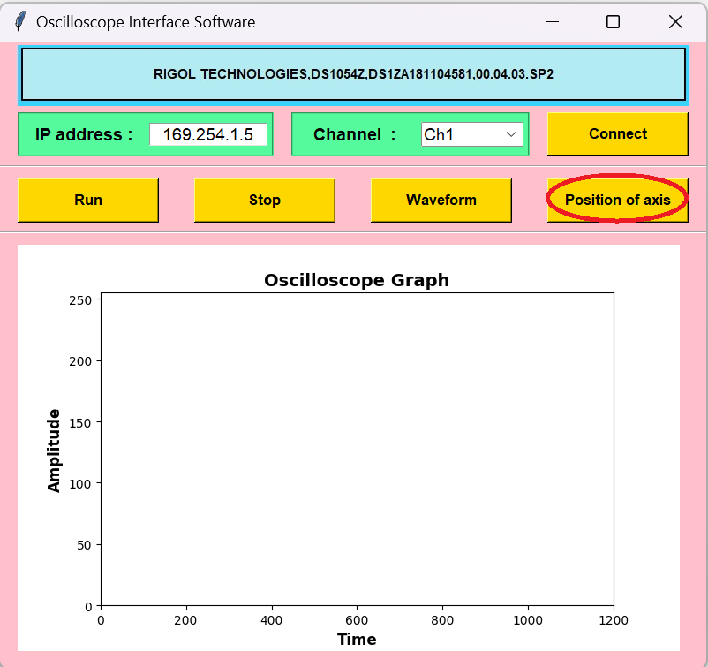

* If the button is pressed when the oscilloscope is running on auto .

**Points = 1200**

**X-Origin = -6e-07**

**Y-Origin = 0**

* If the button is pressed when the oscilloscope is adjusted by moving the wave in the upward direction of Y-Axis .

**Points = 1200**

**X-Origin = -6e-07**

**Y-Origin = 22**

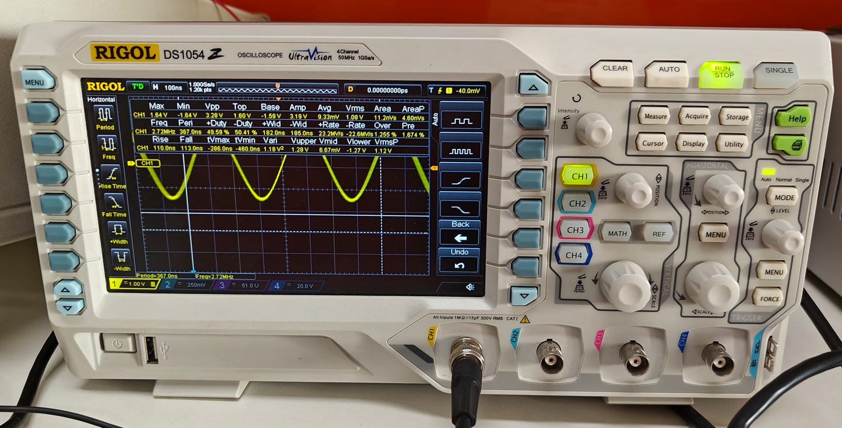

* If the button is pressed when the oscilloscope is adjusted by moving the wave in the downward direction of Y-Axis .

**Points = 1200**

**X-Origin = -6e-07**

**Y-Origin = -70**

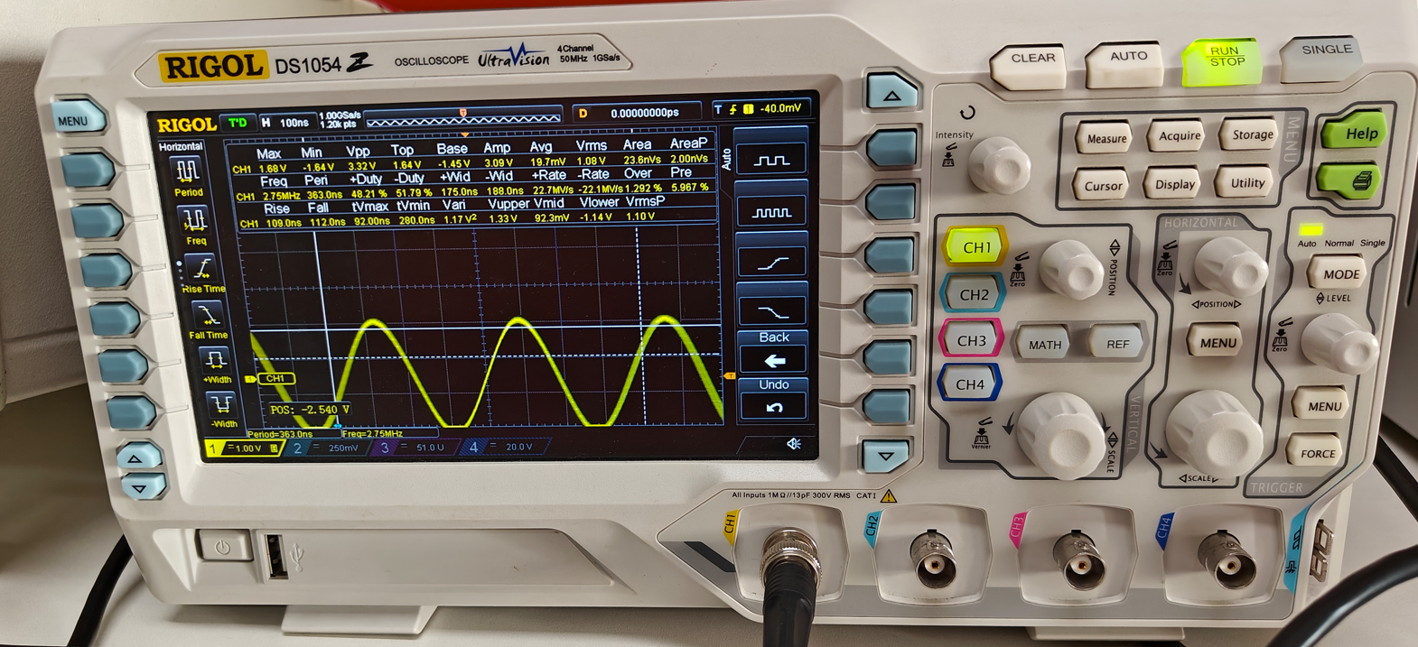

* If the button is pressed when the oscilloscope is adjusted by moving the wave in the rightward direction of X-Axis (maxed out parameter) .

**Points = 1200**

**X-Origin = -1.2e-06**

**Y-Origin = 0**

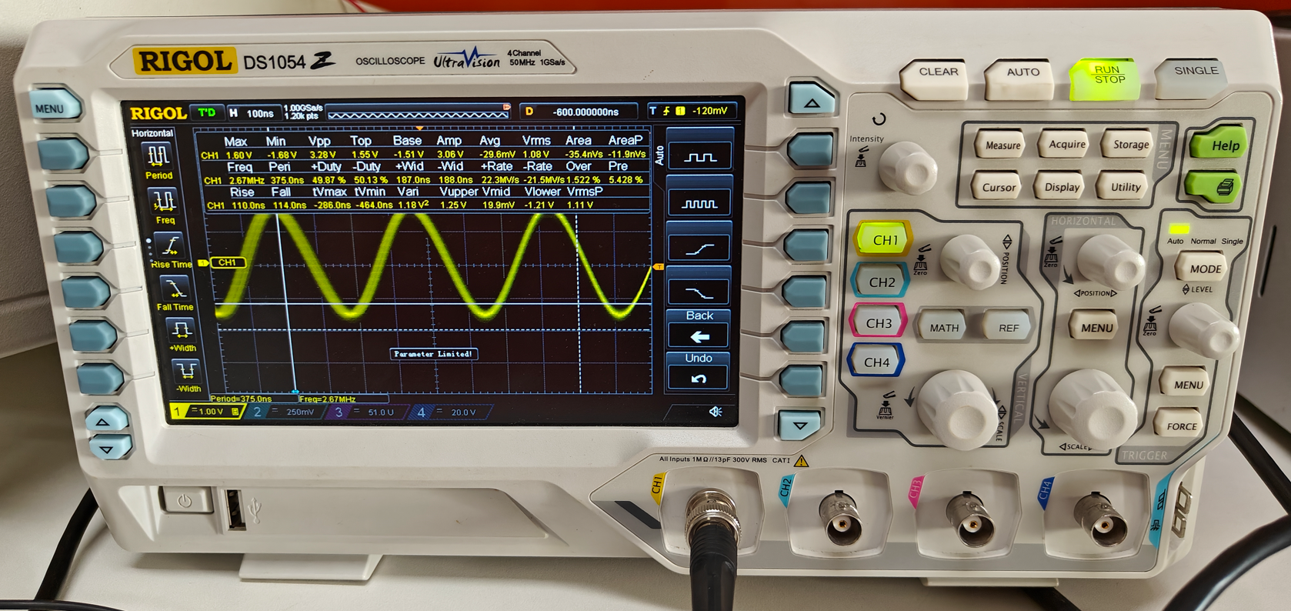

* If the button is pressed when the oscilloscope is adjusted by moving the wave in the rightward direction of X-Axis (maxed out parameter) .

**Points = 1200**

**X-Origin = 2.104e-06**

**Y-Origin = 0**

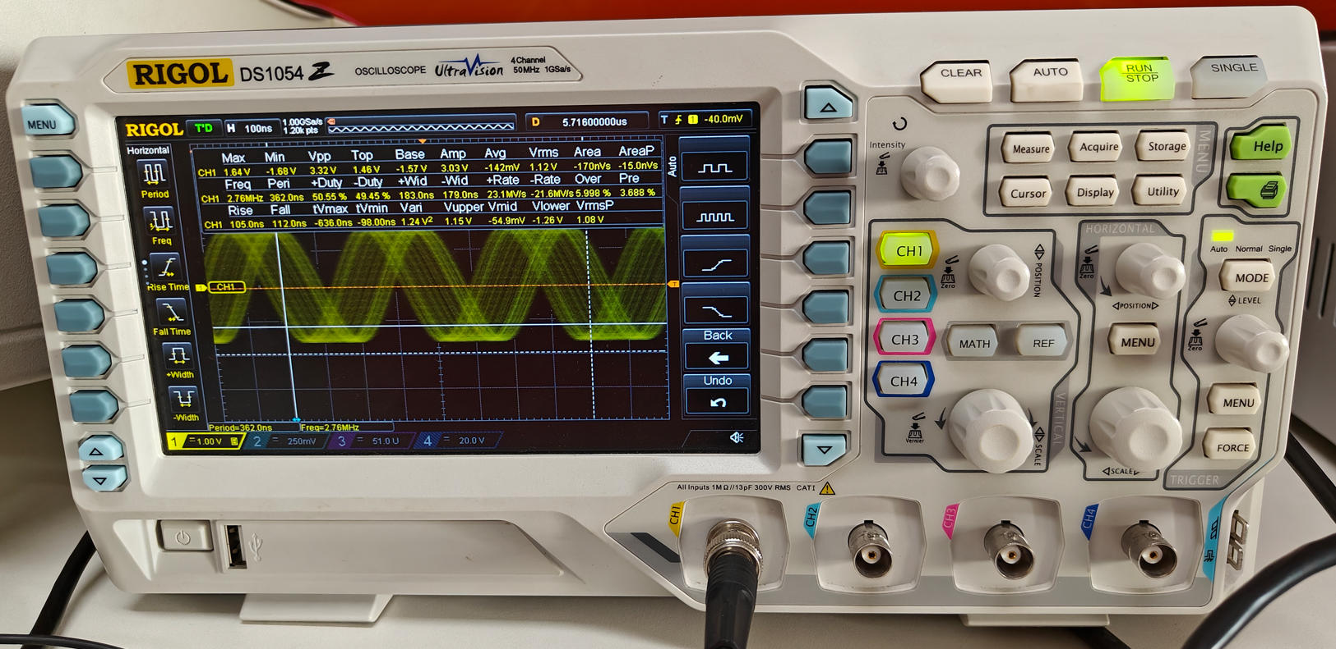

**7. TO TRANSFER OUTPUT FILES**

* Press on Destination Folder button to choose the location to which the file should be given.

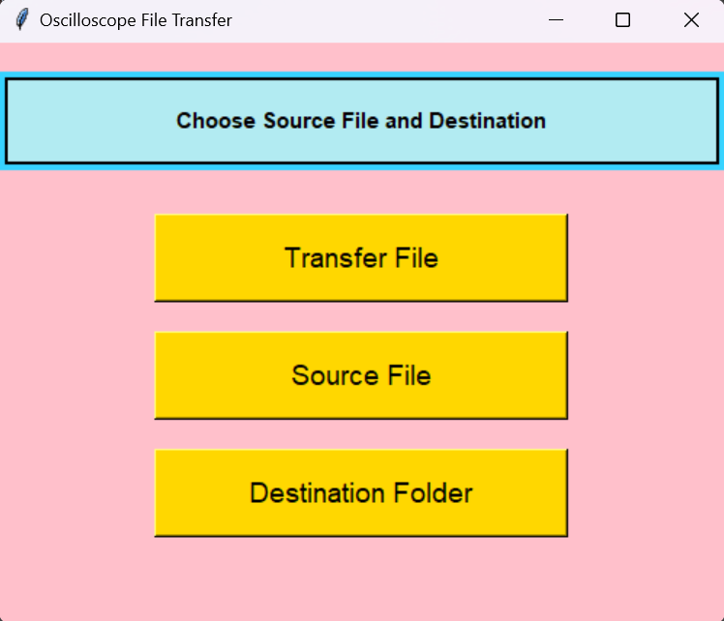

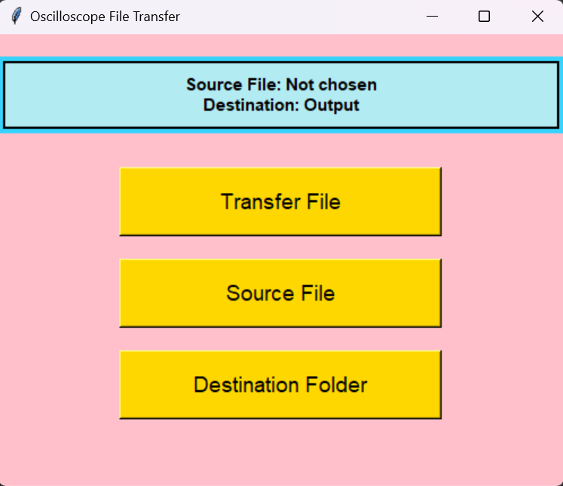

* Press on Source File button to select what to file needs to be transferred.

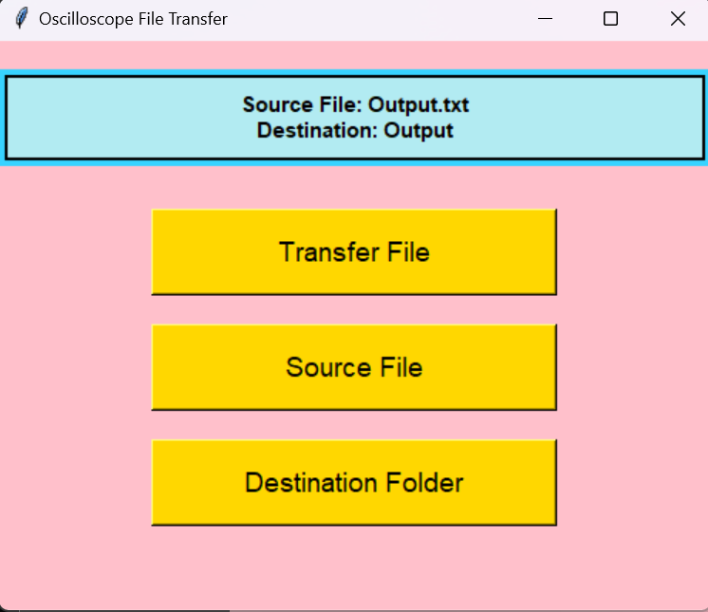

* Double press on Transfer button to transfer the file.

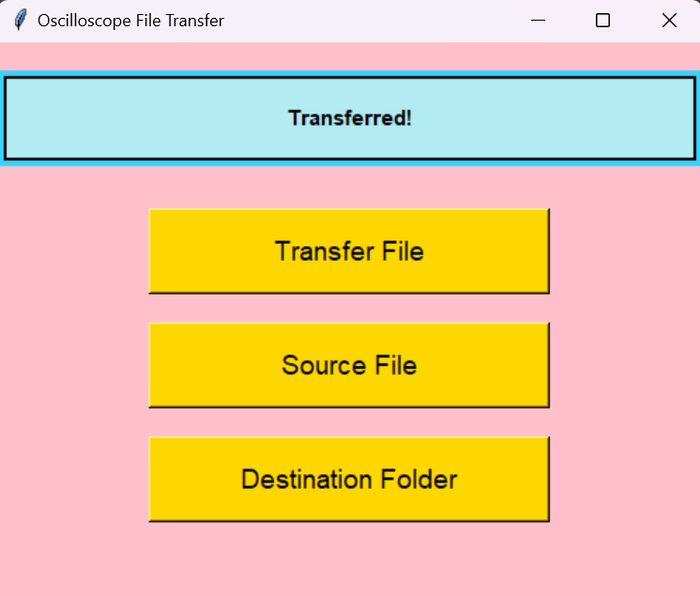

* Example :

